**PRE-WEBINAR TRAINING/INDOCTRONATION VIDEOS (OPTIONAL)  
(See Pic)**

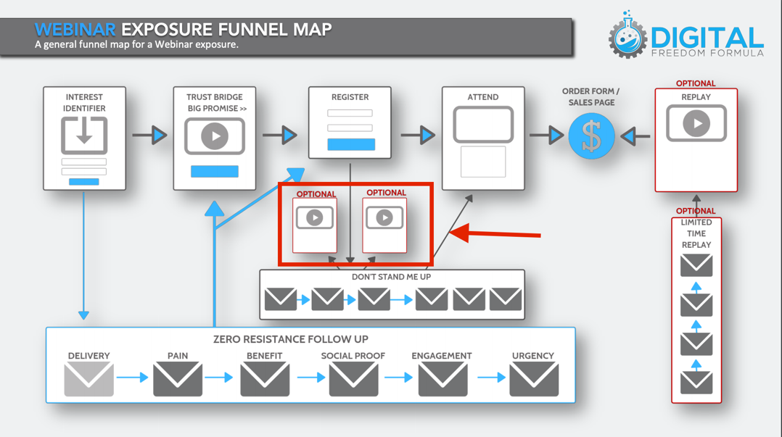

**EXAMPLE 1 of 2 OF (OPTIONAL) PRE-WEBINAR INDOCTRONATION/TRAINING VIDEO SCRIPT**

**This is the first of 2 pre-webinar training videos that go out after registration. This video is designed to teach and tease, pain a picture of benefit, share reasons (possibly statistics) that will make attending even more critical.**

Hey there, Justice Eagan here. I want to thank you again for registering for this upcoming training webinar that you'll be attending. You know, I'm hoping this second video gets to you in time before we start our training. The reason is, is because I've been getting a lot of questions about the training from the people that are registered.

Specifically, lots of people have been asking, "Hey, if I'm not techie, or if I don't have a big social media audience, or I don't have a lot of online experience, can this strategy work for me?" I'm actually really happy that this is the question that's coming up so much because I'm not sure if you were wondering the same thing, but if you're anything like me, I used to spend hours when I should have spent minutes, and weeks when I should've spent days, trying to figure out all the techie internet stuff so I could grow my business online.

I literally barely knew my way around a computer when I got started, and what I discovered is that if you really want something bad enough, you can figure all that stuff out. The really good news is, is that you won't have to, which is what I love so much about what I'm going to be teaching you when you attend. You see on the training, I'll share how you can take an everyday picture paired up with someone else's success story. You don't even need to have results. And then use it with the inner workings of Facebook that most people don't even know about to get that success story out in front of an endless amount of perfectly qualified prospects.

Now, this isn't just your standard testimonial story or the before and after picture type of stuff you see on social media. When you attend this training, you'll learn how to add a few simple, but crazy, effective influence principles to get people responding to these posts like you've never experienced before.

For instance, did you know that by sharing some of your shortcomings, some of your flaws and mistakes, that people will actually trust you more? It's kind of the opposite of what people try and do, right? Most people on Facebook, they're out there trying to be something they're not. They're trying to impress other people. Instead, you can share things that aren't so impressive and actually get a higher response, make more sales, and enroll more people because of it.

Another tip is that when you post about someone else's results on Facebook, you want to do it in a way where the reader of that post, they see something that they can relate to in the story about the other person. Again, just the opposite of what most people do. Most get out there. They want to post the incredible results, right? The million dollar earnings, their rags to riches story of the insane weight loss, or some other best case scenario when in reality what's more important is whether or not the person in that story is a mom, or a part-timer, or someone who's going through similar challenges that the one who's reading it is.

You know, it's not about how great the results are. It's about how much the reader of that post can see themselves in the other person's shoes. Now, I'll go into a lot more depth on that subject on the webinar, but imagine for a moment you were able to predictably get a response from online prospects because you used some of these influence principles. Now imagine that you can take that short story and put it in front of thousands and thousands of people who are already interested or even already purchasing the type of product, service or business opportunity you offer.

I mean, those people really need no convincing whatsoever. It's totally possible. When you attend, I'll show you that Facebook actually knows so much about it's users that they could help you put your super influential post about someone else's success story in front of prospects that are already looking for what you have. Again, no website necessary, no techie set up, no huge audience or experience required.

All you need is a story, a picture, and a Facebook account. Then you need the five step process that I'll teach you when you attend. So if you really want to generate leads, sales and enrollments online without all the technical overwhelm or time spent figuring everything out, not only am I going to make it simple for you, I'm going to show you how you can make it happen in as little as 24 hours.

You know, it gets me thinking about when I first got started online. Now, I remember spending months blogging and cutting videos like I was told to do, only to get zero results. My posts on social media not only got no response, but people actually made fun of them. You know, I remember when a college friend of mine tagged all my other college friends in a post I did and made fun of what I was up to.

"What's Justice doing? You know, he's in one of those things." You know, nothing I was doing was working, and I was trying to do all this stuff online in between home and hotel meetings, and jumping on company calls, and to consuming online trainings, and working my full time waiter job. It wasn't until I began to learn the secret of getting online prospects responding to me, and then learned a bunch of different strategies to help get their eyeballs on my message. The best of which I'm going to teach you on this webinar that everything began to change for me, and selling and recruiting really became effortless.

You know, I've now been able to personally recruit over a thousand people into network marketing and affiliate marketing programs. I've had the good fortune of helping others experience similar results. So if you're anything like I was when I first tried to grow my business using the Internet, definitely show up to this training that you're registered for.

Because remember, my goal is that by the time you leave, you'll be able to get prospects reaching out to you in as little as 24 hours without any of the headaches that most business owners are experiencing. A quick heads up though, this training has a limited number of seats. Once those seats fill up, those who don't get on first are going to get shut out. There's absolutely nothing I can do to change that. And as of right now, I've got no plans of holding a special training like this again.

So in order to guarantee you've got a spot, make sure to set an alarm and show up a good five to 10 minutes early so that you assure yourself a seat. You know, thanks again for registering. I really can't wait to meet you on this webinar, and share more about this really simple strategy that's helped me and my teammates keep a steady stream of prospects coming your way.

I know I can do the same for you. So, I'm really excited to see you there. Take care, and I'll see you soon.

**------------------------------------------------------------------------------------**

**EXAMPLE 2 of 2 OF (OPTIONAL) PRE-WEBINAR INDOCTRONATION/TRAINING VIDEO SCRIPT**

**This is the second of 2 pre-webinar training videos that go out after registration. This video is designed to handle the major objections & reservations your prospect may have about the information that’s being presented on the webinar.**

Hey there, justice Eagan here. And first of all, I want to say thanks for registering for this upcoming Webinar. And I want to tell your real quick what we're going to go over so that you can be prepped to get the most out of this upcoming training. First of all, this webinar training is going to be incredibly different from some that you may have gotten on with others in the past. It's designed to be more like a mini live course on how to start generating leads and attracting interested prospects for your business online. Without a bunch of that techy set up, tons of content creation, or hours spent prospecting on social media. And my goal for you is to be able to leave this training and immediately use what I've taught you to create an influx of qualified leads for your business so you can start increasing sales and enrollments as soon as you put this training to work.

Eric Freeman, for example, went through this exact training webinar that you're going to attend and within a matter of days, he had over 45 highly qualified prospects reaching out to him requesting info about his business and he did it without even needing a website. Now, if you're already generating leads and sales online, good for you, I want to be able to help you increase those results by taking this strategy and using it the way I've been using it lately so that you can use it to grow an email list or even pack webinars. Great marketers and leaders like my bud, Mark Herbart and Vince Reed, have gotten pretty insane results thanks to what I'm going to show you. And personally, this strategy has become the driving force in my business and has allowed me to skyrocket my results while reducing the amount of time that I've had to spend working.

So, regardless of where you're at, this Webinar can be an absolute game changer for you. And I wanted to let you know a little bit about what we're going to cover so you're clear on what to expect when you attend. The first thing I'm going to walk you through is how a recent student used my go to strategy to enroll nine new people in 30 days and a rank advanced twice in his business. We're going to break down exactly what he did, why it worked so well, and how you can implement the exact same thing in your business right away.

Now, you've probably seen promises of online results from different gurus out there before, and many of them will highlight the 97% of home business owners that fail and they'll conveniently point the finger at old school tactics like bugging friends and family, or painfully dragging yourself to home and hotel meetings, or chasing down strangers at shopping malls, right. We've all heard that language before, only to tell you that the Internet's the answer. Well, truth be told, those who turn to the Internet often, fair note better. They get bogged down in technical challenges that you can't find time to create content or they find themselves participating in low leverage activities like prospecting strangers on social media.

So please understand, your success is less about online or offline and it's more about your ability to quickly and easily attract high quality prospects that are perfect for your product, service, or opportunity. That's exactly where Pedro was at before I taught him what I'm going to teach you and he immediately turned things around and enrolled new people in 30 days.

Now many people like Pedro had been rejected by their warm market and have run out of people to talk to, but they're limited on time and don't know where to start when it comes to the complicated world of online marketing. That's why when you attend, I'm going to show you a simple five step process that I've created and perfected over the last 12 months where you can use other people's results combined with some aspects of social media that you might not know about to get your message in front of thousands, tens of thousands, or even hundreds of thousands of ideal prospects and have them literally raising their hand and asking you to share information about what it is you offer.

Now, you may have tried some things online before to generate leads, and get people reaching out you, and all the different stuff that you see getting trained out there online. You may have tried leveraging social media to make more sales and enroll more people in your business, and if you are at all frustrated or disappointed with the outcome of those efforts, then there's definitely a big difference between what you've done and what I'll be sharing with you on this training.

Believe me, I've tried it all, right? I've done tons of different strategies and I've actually had the privilege of teaching thousands of home business owners how to grow their business online. And this is hands down the fastest, easiest, and most leveraged way to get prospects reaching out to you, regardless of your company, regardless of how much time you have, and regardless of your technical knowhow or results up to this point.

So if you've tried to grow your business online before and struggled to get results, or you're concerned that say you're not techy, or that you don't have the time to do online marketing, or you don't have enough results yet that people would actually want to reach out to you and find out about working with you or buying from you. Well, I'll tell you right now, this can not only work for you, but it's actually perfect for you.

Now, we're going to be covering a lot on this upcoming webinar and I'm going to dive deep into this five step process that I've created that anyone can follow to get results. And I value your time. So I want to make sure you come away with the information you're looking for so you can transform your results right after you implement. So we're going to start at 9:00 PM Eastern sharp, and I highly encourage you to get there few minutes early because this is going to be absolutely packed. Set ample time aside, be in a quiet place, make sure you have strong Internet connection and a pen and notebook handy. I can't wait to see you on this training. I'm absolutely positive it is going to blow you away. So mark your calendar, take care, and I can't wait to see you on the Webinar.